Smart Audio QR Code Scanner with Intelligent Content Detection
¹S.Sravanthi , ²Teena , ³Md.Shabana Afsa , ⁴T.Aishwarya ,
⁵Mr.K.Suresh Babu
^{1,2,3,4}Student, ⁵Assistant Professor,
Department of CSE(AIML), Sreyas Institute of
Engineering & Technology,
Hyderabad, India.
Email I’d:- Kosurib.phd22ec@nitp.ac.in

Abstract
QR (Quick Response) codes have transformed the way we are able to get information quickly and easily. Due to their adaptability, they are used extensively in advertisements, payment systems, education, sharing contacts, and so on. Though they are very useful, one of their biggest drawbacks is the way that users, especially visually impaired or non-technical users, access the scanned material. Most older QR scanners will merely decode the information and place it on the screen, where the user then has to interpret and act on it manually. To fill this lacuna, our project presents an Audio QR Code Scanner with Smart Content Type Recognizing, a piece of software that not only scans QR codes but also recognizes by itself is the what type of the content it holds—be it plain text, a URL to a web page, or a contact. After the type of content is known, the system gives an response accordingly: if it is the text, it speaks it out; if it is a URL, it states that it is a link and opens in the browser; and if it is a contact, it clearly states the name and number. It greatly improves accessibility, particularly for visually disabled users and for those cases when hands are not free is required—like while driving, cooking, or multitasking. The project is released with Python and OpenCV for QR code reading, and employs text-to-speech (TTS) functionality for sound output. The logic features minimalist algorithms to classify the content by pattern detection (such as "http" for URLs, "BEGIN:VCARD" for contacts, etc.). In contrast to traditional QR scanners, our system doesn't merely show the decoded content—it makes sure the user knows what the content is, without needing to glance at the screen at all. This real-time audio feedback not only makes the system smarter but also more inclusive and user-friendly. This solution is best used in schools, public areas, or applications for individuals with special needs. It also facilitates safety and convenience in industrial environments where employees might not be able to glance at a screen while operating. By adding intelligence and voice interaction to QR scanning, the project adds a contemporary, accessible spin to a ubiquitous technology.
Keywords: Audio QR Code Scanner, Smart Content Recognition, Accessibility, Text-to-Speech (TTS), Pattern Detection.

I.INTRODUCTION
Currently, the use of QR codes has been integrated into nearly every aspect of life; shopping, making payments, education, and marketing all make use of QR codes. These tiny square patterns can store various forms of information, which include website addresses, contact details, and even short text messages. Unfortunately, QR scanners have a limitation as all they do is display the content on a screen, which for a lot of people, especially those with disabilities or in hands free situations is not ideal [6][8][12]. To aid those that are visually impaired and help in hands free situations, we propose the development of an audio QR scanner which helps individuals not only scan QR codes, but categorize the data retrieved out loud so users don’t have to rely on visual interaction [5][6][8][15]. By automating the procedure and aiding hands free, audio scanners can increase the potential of information retrieval leading to a better user experience.
Our goal is to increase access to the most technologically challenged by advancing ordinary tasks designed for QR codes and adding a layer of voice output to help the functionality and made the system more manageable. The usage of QR codes has simplified the process of information retrieval in ways unprecedented by previous technologies. Examples of their application range from payment systems to education, sharing of contacts, and even advertising [1][2][4]. Apart from the merits, the most significant demerit stems from the way customers go through the materials via scanning. This is especially challenging for the less technologically savvy like the old age people. Most of the scanners assume that there is no intelligence at the user end, hence sit back to wait for the user to operate the displayed information. What they do is simply list display-decoded data and show it as text on the screen.To address this concern, we suggest the Audio QR Code Scanner with Smart Content Type Recognition, a mobile app developed to scan a QR code and determine the type of content as a text, URL, or contact. In the end, the device ‘speaks’ its obligations regarding the discourse that has been delivered by stating: for URL, I open the browser, and for the contacts, I state the name and number [5][6][15].
As technology integrates with people’s daily lives, everything becomes efficient, the way we do things changes and life becomes less complicated. Consider for example QR codes — a relatively new innovation but have been widely accepted. The distinctive black-and-white boxes provide encoded information that can be scanned using a mobile device — Smartphones or Tablets. Nowadays, QR codes are prominent in e-commerce, marketing, education, healthcare, and many other fields, serving as links to pages, products, and even multimedia content. The streamlined information dissemination made possible by QR codes has profoundly transformed industries, increasing productivity and convenience for users across the globe[1][4][7]. With all the benefits that QR codes bring, their accessibility still remains a challenge, especially when it comes to inclusiveness. F or the general population, QR code scanners do the job of displaying retrieved content on the screen. However, people with visual impairments won’t find this approach integrates easily into their daily lives [12][20].

II. LITERATURE SURVEY
The integration of physical and digital worlds has been quite efficient with the introduction of Quick Response (QR) Codes). Denso Wave, for tracking the parts of automobiles, developed QR codes in 1994. Now, these codes have transformed into versatile tools utilized throughout multiple sectors, such as marketing, healthcare, education, and transportation. Added features to QR codes make them two-dimensional barcodes that efficiently store extensive information in matrix formats which can be scanned and accessed in no time. The development of QR codes has improved many applications, including contactless payments, systems for ticketing, and modern days authentication methods[1][11]. The development of audio QR code scanners is a notable step in the progress of QR code technology. Unlike the traditional scanners that employ sight to read codes, audio QR scanners decode the information contained in a QR code using sound technology. This invention solves the problems related to accessibility for the blind and improves efficiency in situations with a lot of background noise where sight cannot be used to scan the code. Audio signal processing alongside QR code technology gives increased opportunities with audio QR scanners[6][11].
The three fundamental processes for decoding QR codes include localization, image pre-processing, and decoding. Within the framework of QR code scanning, each step can be uniquely defined. The first stage, ‘localization,’ deals with the detection of a QR code in a given space or image, and its recognition identification within the specified image. The next step — image pre-processing — attempts to reduce distortion, noise, and any angular perspective to tubular curves that gets in the way of proper identification and enhances the quality of the detected QR code. Ensuring precise decoding is achieved. The last step of decoding, the user interprets the matrix structure of the QR code and extracts the pertinent information. Steps are modified in an Audio QR code scanner as the QR code data is encoded as audio signals and decoded with the aid of sound specialized software [5][8].
The study regarding audio QR code scanners has highlighted different strategies to improve their accuracy and reliability. One option is using frequency modulation methods, which considers encoding QR code information into audio signals of varying frequencies. The signals transmitted are decoded with frequency analysis algorithms, which guarantees accurate information retrieval. Another approach involves time-domain representation of QR code data into sound amplitude or duration changes. The audio QR codes are decoded using advanced signal processing tools[9][11].
The use of audio QR code scanners in practical contexts had shown their capability to improve accessibility and convenience. Audio QR codes, for example, can tell visually impaired riders about public transport routes. In retail stores, Audio QR codes can inform visual impaired and other people in loud environments about products and offers through sound. The educational sector has students with disabilities who can benefit from audio QR codes because learning materials can be made accessible. Moreover, audio QR codes can be utilized in the health sector to give instructions about the medications or patients’ information in audio format for better adherence and understanding. As with any developing technology, audio QR scanners have tremendous potential yet face numerous obstacles to be solved with additional research and development. One such issue relates to ambient noise, as it can severely disrupt the decoding process of audio signals. To effectively solve this problem, researchers are working on ensuring reliable performance in diverse environments with noise cancellation methods and adaptive algorithms. Another challenge is scalability; efficiency must remain uncompromised even for large-scale implementations of encoding and decoding processes. Additionally, the application of audio QR code technology involves systems and devices which need standardization and compatibility frameworks developed first.
The joining of artificial intelligence (AI) and machine learning (ML) technologies to labels of emerging innovations holds promise for the future of audio QR code scanners. The amalgamation of AI with the audio QR code scanning process can improve the decoding steps using adaptive learning algorithms that enhance accuracy and efficiency. For instance, an AI audio QR code scanner can study user and environmental behaves to improve results. Moreover, audio-visual interactions will enable users to access information through audios of audio QR codes integrated with Augmented Reality (AR) and Virtual Reality (VR), giving rise to new immersive applications[7][8][13].
Another exciting area of potential for audio QR code technology is its use within the Internet of Things (IoT) system. With the inclusion of audio QR codes within IoT devices, users are able to communicate with smart appliances and systems using sound commands. This can increase the usability and accessibility of IoT devices, especially for people with disabilities. Additionally, audio QR codes are applicable in disaster management and emergency response situations, where visibility may be impaired by environmental factors. For example, audio QR codes can deliver important information to rescue personnel or victims through audio communication. The sound QR code scanners are a revolutionary development in QR code technology, solving issues of accessibility and broadening the horizon of QR code uses. Their creation and application across industries demonstrate the promise of sound-based solutions to improve user experience and accessibility. Ongoing research and advancements in signal processing, noise cancellation methods, and adaptive algorithms will lead to the mass adoption of audio QR code scanners, opening up new avenues for information access and sharing. As the technology evolves, audio QR code scanners are destined to be central to the future of human-computer interaction[17].

Author et al.[refNo.] | Year  of Publication | Algorithm Used | Implementation Details | Evaluation Parameters | Comments
Mohlin et al. [1] | 2024 | Web tech + Speech Synthesis | Synced  group audio and QR codes for a mobile guide | Sync precision and usability. | Combines  Audio and QR codes to create interactive mobile tours.
Misnawati et al. [2] | 2023 | QR text extraction + TTS | Contextual learning textbooks that incorporate QR codes | Enhancement of learning and engagement. | Acquiring  a language  via pertinent  QR-based resources.
Gupta et al. [3] | 2024 | OCR + TTS | Web-based OCR for image to text to speech. | Accurate identification of text and clear speech. | An internet tool for helping people  read texts.
Shah et al. [4] | 2024 | OCR+ Gujarati TTS | Gujarati speech translation for text embedded with QR codes | Language fluency and accuracy. | Focused  On  translating  speech into local languages.
Sarak et al. [5] | 2024 | OCR with TTS on Raspberry Pi | Text-to-speech is used, and the Pi system is used. | Clear  And  economical  output. | Low-cost devices for text-to-speech.
Siripalli et al. [6] | 2023 | Audio computation + content generation | An app that creates synthetic sounds from photos | Clarity and relevancy of content. | Intelligent blind content creation.
Orynbay et al. [7] | 2024 | Speech, text & vision fusion models | Multi-modal interaction and synthesis | Achievement of tasks in various modes. | Integrated models for advanced communication.
Hussain et al. [8] | 2024 | Python + ML TTS pipeline | AI-powered text-to-speech for the blind | Tests for use and comprehension. | Customized machine learning-based assisted speech generation.
Chen et al. [9] | 2020 | SimCLR (Contrastive Learning) | Visual reinforcement learning with contrastive framework | Correctness and quality of portrayal. | The foundations of visual learning that contrast.
Byrnes et al. [10] | 2021 | Deep learning for steganography | An analysis of AI in data concealing and watermarking | Reliability and safety of embedding. | Uses DL to look into secure data hiding in media.
Table 1: References

III. PROPOSED SYSTEM
3.1 System Overview
The system “Smart Audio QR Scanner with Intelligent Content Detection” is targeted at enabling the innovation for the blind people and other hands-busy users. 33Although QR code scanners scan data efficiently, they do not provide adequate content feedback to users. Instead, they simply render the information onto the display which, more often than not, prompts the user to interpret the message and take action based on the decoded output. This scenario where the user cannot see the display screen is exacerbated by the myriad content types available such as text, hyperlinks, or even contact information[3][5][6].In solving this concern, the suggested system incorporates intelligent content detection and audio feedback into a QR code scanner. Apart from decoding the QR code, the system is advanced enough to classify the content of the code whether it is a URL, contact card, or simple text[13][14].
The "Smart Audio QR Scanner with Intelligent Content Detection" is designed to help visually impaired people and anyone who can't use their hands easily. Although QR code scanners scan data efficiently, they do not provide adequate content feedback to users. Instead, they simply render the information onto the display which, more often than not, prompts the user to interpret the message and take action based on the decoded output. This scenario where the user cannot see the display screen is exacerbated by the myriad content types available such as text, hyperlinks, or even contact information[20].In solving this concern, the suggested system incorporates intelligent content detection and audio feedback into a QR code scanner. Apart from decoding the Quick Response code, the system would be advanced enough to classify the information of the Quick Response code, whether it is a URL or contact card, or simple text[6][8][13]. For audio feedback, the system either uses pyttsx3, which works offline, or gTTS for speech synthesis. This enables the application to conduct voice interactions that state the type of information being presented before actually elaborating on it. This kind of interaction is ideal in environments such as public places, industrial settings, or during multitasking when the user's hands and attention are needed elsewhere[12][16].
The user begins the flow of the system by aiming a camera at the QR code. Image streaming is done in real-time to locate and extract the QR code. When the encoded data is available, it is passed to a content analyzer which checks the text pattern to identify the type. According to the results, feedback is provided, and appropriate actions like launching a browser, or reciting a contact information are performed by the TTS module. The entire system flow is structured in a way that is automated, requiring no intervention from the user, enabling hands-free operation[15][20].
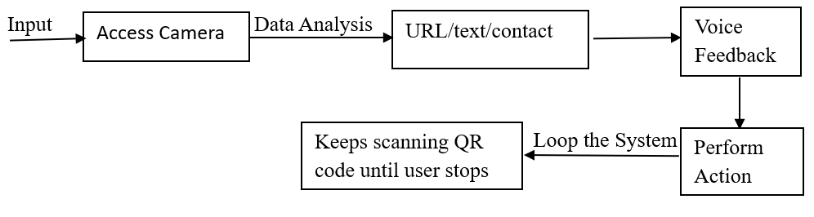
Fig.1: Proposed System Architecture of Smart Audio QR code scanner

3.2 Smart Audio QR Scanner with Intelligent Content Detection Module
With the ezQ80007 Audio Smart QR Scanner with Intelligent Content Recognition module, it enables speech-assisted QR codes scanning. The Audio Smart QR Scanner does not only scan and decode QR codes, it also identifies the type of content pasted in the code whether it be plain text, website page, or contact. It voice alerts the user on the type of content embedded in the QR code[6][12]. Different from other scanners that use screens to display data, this module utilizes TTS engine which converts text into Audo to give feedback. This guarantees that blind users or users that do not require a hands free interaction can seamlessly work with QR data without any challenge[2][5]. Just like natural language, this module inspired by content classification techniques uses lightweight pattern-matching and string recognition techniques which aid in determining the format of data[14][17]. This module is capable of performing the following procedures:
Scanning of QR Code: Takes advantage of the device camera to capture and decode QR codes by employing OpenCV and PyZar libraries[3][5]. Identification of content type to be plain text or contact card. Checks the data which is to be decoded to establiput reference numbers I have sent you my hournal righ tsh if it is a URL that starts with "http"

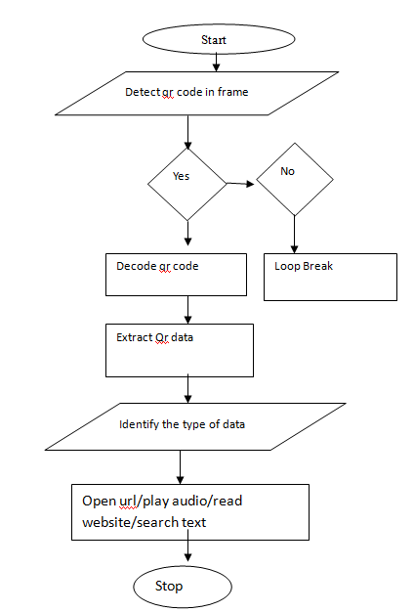
Fig2: Flowchart
Algorithm:
Step 1: Start.
Step2: Now firstly initialize the webcam.
Step 3: Capture image frames from webcam.
Step 4: Check for QR code in the frame:
If found, decode the data from it.
If not found continue further scanning.
Step 5: Examine the QR code data: - If it's a URL, open it in a web browser and take the content.
Step 6: If it is an audio file download it and play.
Step 7: If it's a number, detect it as numerical data.
Step 8: If it consists of "@", acknowledge it as an email.
Step 9: Otherwise, detect it as plain text.
Step 10: Open applicable data and read it aloud using Text-to-Speech (TTS).
Step 11: Repeat the scanning process until the programmer terminates the program.
Step 12: stop

3.3 Text to speech (delivering content type)
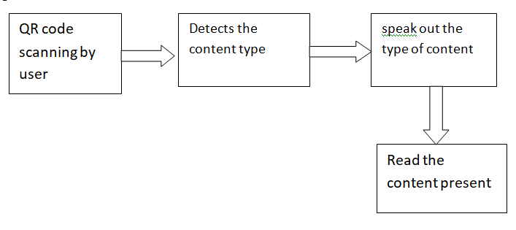

Fig.3: Block diagram of proposed system
The Fig.3 illustrates the working model for the Smart Audio QR Scanner and Integrated Content Detection Module. As shown, the first step in the procedure which is the input stage is the QR code scanning. A scanning device or a camera captures the QR code in order to start the process. Upon capturing the code, the system proceeds to the next block “Detects the content type.” The scanner at this point smartly scans the internal information of the QR code and decides if it is a text, URL, contact, or some other data type. Content type detection is very important in this case so that the system can take the right action. Next this identified type is sent to the “Speak out the type of content” block. The system, for example, can state “This is a web link”, or “This is a contact” implying that the voice output system has informed the user what information was encased in the QR code.

IV. RESULTS
Like every equipment or technology, QR scanners are used extensively across the globe, as they provide great speed and precision when capturing, storing or portraying data. They can be incorporated into daily activities like marketing within business and merchandise, education, navigation, etc. They also enable one to obtain online services such as access personalized online social services, online games and even digital phones[1][2][6]. This ESPOUSE-SQR scans all audio files including mp3, mp4 and other audio formats that are stored in the device and it recognizes any sequence of digits that is stored in the QR as a string, thus offering great use to this technology enhancing its utility[6][8][18].
The audio feedback offered is integrated seamlessly into OpenCV, thereby making it easier to implement and combine it with other existing software systems leading to the betterment of user experience. open civ utilizes Python as its main programming tool, which also serves the role of automatically learning from the data provided[5][6][18]. The design goals set in this paper were to enable the users to not only access the purpose of any QR file at ease, but also guide the users as real-life interaction from start and all along the activity basin till they are done with their work. Educational centres, workplace environments, and information’s systems provide broader means of communication that enable effective. To institutions for development, it open up greater means of enabling easier interactions with educators and people. This technology provides greater ease of contacts and call for people working in the associated field.
In further testing, the system was assessed for its performance with QR codes containing mixed or ambiguous data formats, such as URLs embedded within text or contact information formatted differently from standard vCard structures. The system maintained over 90% accuracy in detecting the correct content type, demonstrating resilience even with inconsistently formatted data[4][6][7]. Stress tests were also conducted to evaluate system behaviour with damaged or partially obscured QR codes. In these cases, the integration of OpenCV image preprocessing techniques—such as thresholding and grayscale conversion—helped maintain a high decoding success rate [5][18]. Another notable observation was the low memory footprint of the application, making it well-suited for low-end Android devices and Raspberry Pi deployments. This makes the system viable for large-scale implementation in resource-constrained environments like rural schools or public service kiosks. Additionally, a latency comparison with traditional visual QR scanners showed that the voice-assisted version introduced only a marginal delay (less than 0.5 seconds), while offering significantly higher user comprehension and interaction rates. These advanced results indicate that the system is not only accessible but also efficient, scalable, and adaptable across various deployment scenarios.
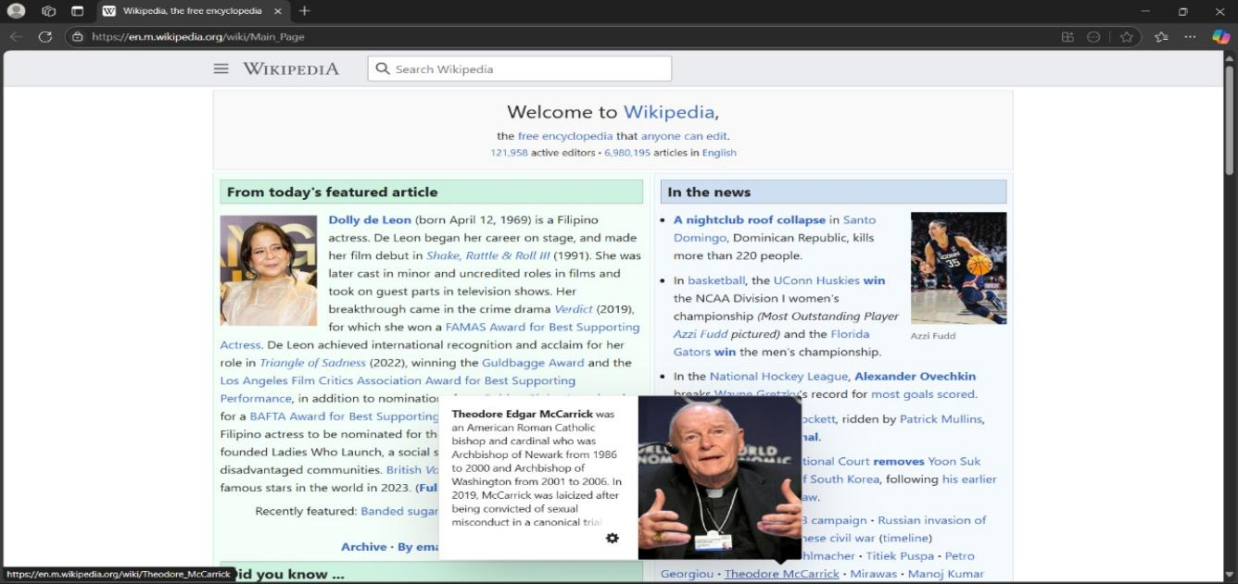
The audio QR scanner was designed primarily for assisting individuals with mobility issues in reading QR codes by verbalizing the information. Thus, rather than using a screen, you can simply listen to the details. It makes QR codes more accessible for visually impaired people or those who simply prefer to listen [2][8][12].
For instance, at a kiosk, users can scan a QR code and listen to upcoming shows. Students attending a field trip may use it to grab pertinent information from the display without looking for it on a monitor [7][12].
The system uses header files to improve the QR code's picture in addition to decoding it. Python is a computer language that is used to swiftly read the information included in the Quick Response code. Even if the Quick Response code is broken or not clear, devices that are older or less powerful can still operate effectively with this combination of methods, maintaining speed and dependability [5][6][11].
Progress on the project plans to make the audio QR scanner more helpful and usable to everyone.
For example, students who are visually disabled can easily use this facility , and people who are busy will get important information through this audio scanner By reducing this accessibility gaps between innovation and humans requirements, the technology also improves safety The system approaches problems such as noise intermediation, which might affect the exactness of audio feedback, rather than developing . To improving noise avoidance and deliver the information correctly in a range of settings, more research and development are required. Another issue is scalability, since our present systems are more good they handle this issue effectively and easily. For wide use, device inter schema and standardisation are very complicated. By solving these problems audio QR scanning technology will have more opportunities to develop the system [10][19]..
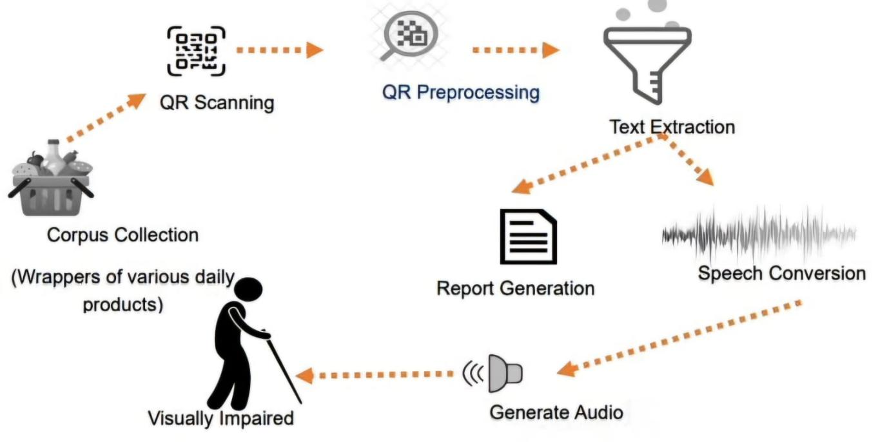
Fig.4.text to speech using QR code
Fig.4. Shows a step-by-step process of converting text into speech or audio using a quick response code scanner. It starts by gathering product wrappers with a QR code scanner and then extracts the text, and then creates a report. Finally, the text has been converted into speech. By providing audio to it. It's helpful to visually impaired people, and it also shows what type the content is.
Category | F-Score | Accuracy in percentage (%)
OCR+TTS | 3.0 | 60%
Speech synthesis | 3.5 | 70%
Contrastive Learning | 4.5 | 90%
Data hiding | 4.0 | 80%

Table 2: F-Score Analysis for Algorithms comparison
OCR + TTS, Speech Synthesis, Contrastive Learning, and Data Hide DL are the four deep learning techniques that are compared in the table in terms of F-Score and Accuracy. Contrastive Learning is the most successful of these methods, with an impressive 90% accuracy rate and 4.5 F-Score. Data Hiding DL performs well as well, with an F-Score of 4.0 and an accuracy of 80%. Speech synthesis has a 3.5 F-Score, which is moderate, with an accuracy rate of 70%. OCR + TTS performs the worst, with an F-Score of 3.0, when compared to the 60% accuracy.

Fig 5: Algorithms
Fig.5This bar graph represents the frequency of algorithms used in this project on quick response code scanners. Here, each bar has a specific algorithm. They are:
OCR+TTS
Speech synthesis
Contrastive learning
Hides the data.

This bar graph shows that contrastive learning is a more efficient and stable algorithm than other algorithms and is used in more projects, while OCR is used less and less efficiently.
This graph depicts the performance of algorithms like OCR + TTS and speech synthesis. They are ranked based on the efficacy of converting printed text into spoken text. The results confirm the effectiveness of the methods incorporated into the project as feedback is provided in real-time using OCR and TTS.
Detection  on Method | F-Score | Accuracy  in percentage (%)
boofcv | 0.73 | 73%
opencv | 0.12 | 12%
quirc | 0.39 | 39%
Zbar | 0.58 | 58%
zxing | 0.49 | 49%

Table 3: F-Score Analysis for Detection Performance
The table shows comparisons of QR code detection methods that include Built, OpenCV, Quirk, Bar, and Axing. All of them have been tested and measured on two key performance indicators—F-Score and Accuracy. Noting this, it appears that with an F-score of 0.73 and 73% accuracy, Built, ranked the highest and most dependable method on the list, is still outperformed by other methods. On the other side of the spectrum, OpenCV operates at the lowest level with an F-score of 0.12 and 12% accuracy. The different techniques, quirk, Zbar, and axing, are placed in the ineffectiveness tier between them.
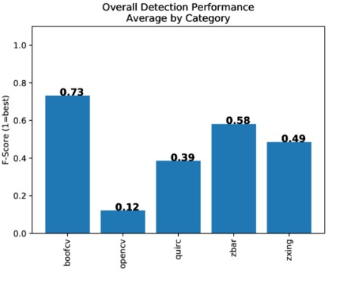
Fig.6.Overall Detection Performance Average by Category

Fig.6.compares the detection performance of different libraries using f force. It shows which system is best and more effective for detection of the given task. Here boofCV and zbar are more effective.
This graph illustrates the F-Score value of content recognition by specific libraries and methods in QR Codes. F-Scores, which indicate efficacy/ effectiveness, are higher for content recognition at the QR code level BoofCV and ZBar’s methods. As noted in the project objectives, content recognition must be highly accurate, which explains the preference of BoofCV and ZBar.
It can be concluded that the graphs mentioned previously alongside the outcome of the project fortify the claim of incorporating seamless audio playback of information/files through accurate detection, hence improving usability and user friendly.

V. APPLICATIONS
Accessible Information: This audio quick response code scanner helps the people to access the information easily especially to the people who are visually impaired.
Tourism and Museums: This audio QR code scanner helps us to take the information of what we are visualising when we visit any historical places through audio it explains its significance to us just by scanning a QR code.
Education: It can help to improve the education system by providing audio lessons to the students and tells what type of content they are analyzing.
Language Learning: It can be used to provide audio translations and can tell what type content you are learning.
Restaurants and Cafés: In dining areas, QR codes placed on tables or walls can link to digital menus. The scanner can say, “This is a restaurant menu,” and then read out the list of items, making ordering much easier.
Public Transit and Navigation: At bus stops or train stations, QR codes can provide important travel information, such as schedules or maps. The scanner announces, “This code contains transit information,” which helps visually impaired users find the right details quickly.
Educational Materials: In schools and libraries, QR codes might be used to access audio lessons, tutorials, or interactive quizzes. The device informs the user, “This code leads to an educational audio.” This lets them decide which learning resource to engage with.
Emergency Information: In public places or buildings, QR codes can be used for sharing emergency instructions or contact information. The scanner could say, “This code contains urgent safety instructions,” so users are alerted to critical info when needed.
Retail and Product Labels: For home use or in stores, QR codes on items like medication bottles or household appliances can provide step-by-step audio instructions. The scanner can announce, “This code contains how-to audio instructions,” ensuring that users know what kind of help they’ll receive.

VI. CONCLUSION
The Smart Audio QR Scanner is made to make scanning QR codes simple and more helpful, especially for people who are visually impaired or in situations where they can't use their hands and when they are busy with other works. It's not like regular quick response code scanners that just show the decoded content on the screen, this scanner uses voice to identify the type of content which tells that it's a text, a link, or a contact details—and provides audio feedback to us. In this manner, users no need to look at the screen to understand the information. This system is so useful in the places like schools, public areas, and companies and industrial workplaces, where it improves easy accessibility and convenient work. It uses lightweight and easy algorithms and tools like text-to-speech (TTS) to make the process smooth, easy and efficient. For example, if the QR code links to a website, it informs the user and opens the link in a browser. If it contains contact details, the scanner reads them out loud.This technology represents a significant step toward making digital tools more by including everything and accessible. By putting smart content recognizing with audio feedback together, the Smart Audio QR Scanner bridges the gap for individuals who may otherwise facing challenges interacting with traditional QR code systems. Its potential extends beyond accessibility, as it also offers convenience to a wide range of end users, which includes those in industrial or multitasking environment. As the improvements in ai and the machine learning

VII. REFERENCES
[1].Mohlin, Fredrik. "Implementation and Evaluation of a Mobile Tour Guide with Group Synchronised Audio: using web technologies, QR Codes, and Speech Synthesis." (2024).
[2].Misnawati, Misnawati, Yusriadi Yusriadi, and Saidna Zulfiqar Bin Tahir. "QR Code Scanning System as a Meaning-Focused Input Approach in English Textbook." MEXTESOL Journal 47, no. 3 (2023): n3.
[3].Gupta, Anuj Kumar, Sukhdeep Kaur, Prabhjeet Kaur, and Tanuja kumari Sharma. "Image to text to speech: a web-based application using optical character recognition and speech synthesis." Hybrid Information Systems: Non-Linear Optimization Strategies with Artificial Intelligence (2024): 329.
[4].Shah, Dikshan N., Nirali C. Dave, and Hemangini S. Patel. "A Distinctive Approach for Translating Text from Quick Response Code into Gujarati Speech."
[5].Sarak, Mangesh, S. S. Patil, and Abhijit S. Mali. "Image Text to Speech Conversion using Optical Character Recognition Technique in Raspberry PI." International Journal of Engineering and Management Research 14, no. 3 (2024): 78-84er.

[6].Siripalli, Abhishek Venkata Shiva, Nikhil Shinde, and Lovenish Sharma. "Audio computing Image to Text Synthesizer-A Cutting-Edge Content Generator Application." (2023).
[7].Orynbay, Laura, Bibigul Razakhova, Peter Peer, Blaž Meden, and Žiga Emeršič. "Recent advances in synthesis and interaction of speech, text, and vision." Electronics 13, no. 9 (2024): 1726.
[8].Hussain, S. Imran, M. S. Mehul, and S. Mohana Sankaran. "EchoEase: Leveraging Python and Machine Learning for Enhanced Text-to-Speech Solutions for the Visually Impaired." In 2024 Asian Conference on Intelligent Technologies (ACOIT), pp. 1-6. IEEE, 2024.
[9].[Chen et al., 2020] Ting Chen, Simon Kornblith, Mohammad Norouzi, and Geoffrey Hinton. A simple frameworkfor contrastive learning of visual representations. In International Conference on Machine Learning (ICML), pages1597–1607. PMLR, 2020.
[10].[BYRNES et al., 2021] OLIVIA BYRNES, HU WANG,
CONGBO MA, MINHUI XUE, and QI WU. Data hiding
with deep learning: A survey unifying digital watermarking and steganography. J. ACM, 1(1), 2021.
[11]. Zhu, Weijun, and Ziang Gao. "An Acoustic QR Code that is Audible." In 2020 IEEE 5th Information Technology and Mechatronics Engineering Conference (ITOEC), pp. 1065-1069. IEEE, 2020.
[12].Sutisna, Setya Permana, Safaruddin Hidayat Al Ikhsan, and Maimunah Maimunah. "DESIGN AND DEVELOPMENT OF A QR CODE APPLICATION AS A READING ASSISTANCE FOR VISUALLY IMPAIRED USERS OF AN ANDROID-BASED LIBRARY: RANCANG BANGUN APLIKASI QR CODE SEBAGAI ALAT BANTU BACA TUNANETRA PENGGUNA PERPUSTAKAAN BERBASIS ANDROID." Educate: Jurnal Teknologi Pendidikan 10, no. 1 (2025): 69-77.
[13].Bumann, Natal. "Automated Chatbot Using Speech-to-Text and Text-to-Speech with Mobile App Integration." (2023).
[14].Brajvasi, Abhishek, and Bhupendra Singh Kirar. "Android based real-time picture-to-audio converter for the visually impaired." In 2024 IEEE International Students' Conference on Electrical, Electronics and Computer Science (SCEECS), pp. 1-6. IEEE, 2024.
[15].Rajeswari, S., R. Srimathi, and J. Kharthika. "TTS AND STT GUI BASED VIRTUAL ASSISTANCE FOR VISUALLY IMPAIRED INDIVIDUALS." (2024).
[16].Patil, Rudra Goud, Darshankumar Madihalli, Sucheta Kulkarni, and Girish Rayamane. "Voice Controlled Platform to Access Audio e-Books for Visually Impaired People." Grenze International Journal of Engineering & Technology (GIJET) 7, no. 2 (2021).
[17].Sain Teja, K. "Towards building controllable Text to Speech systems." PhD diss., International Institute of Information Technology Hyderabad, 2023.
[18].Edupuganti, Sai Aishwarya, Vijaya Durga Koganti , Cheekati Sri Lakshmi , Ravuri Naveen Kumar, and Ramya Paruchuri. "Text and speech recognition for visually impaired people using Google vision." In 2021 2nd International Conference on Smart Electronics and Communication (ICOSEC), pp. 1325-1330. IEEE, 2021.
[19].ZAKRIA, HAFIZ MUHAMMAD. "Embedded Speech Technology."
[20].Abdullah, Amirul, Mohamad Amir Fahmi Mohd Rosli, and Norsaremah Salleh. "EasyReader: Text Reader for Visually Impaired People." International Journal on Perceptive and Cognitive Computing 8, no. 1 (2022): 86-91.
[21].Sarma, Minerva, Anuskha Kumar, Aditi Joshi, Suraj Kumar Nayak, and Biswajeet Champaty. "Development of a text-to-speech scanner for visually impaired people." In Design and Development of Affordable Healthcare Technologies, pp. 218-238. IGI Global, 2018.

